Follow these steps to send your evaluation form directly to your evaluator
Step 1: Sign into Base Camp
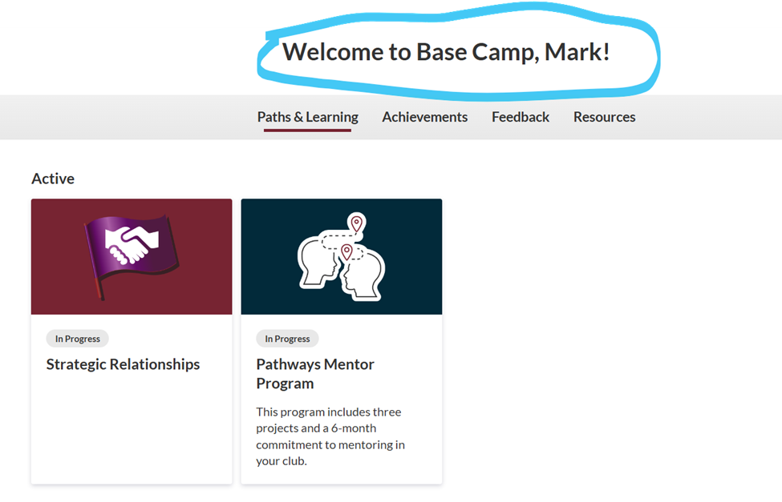

Step 2: Click on the Feedback Button

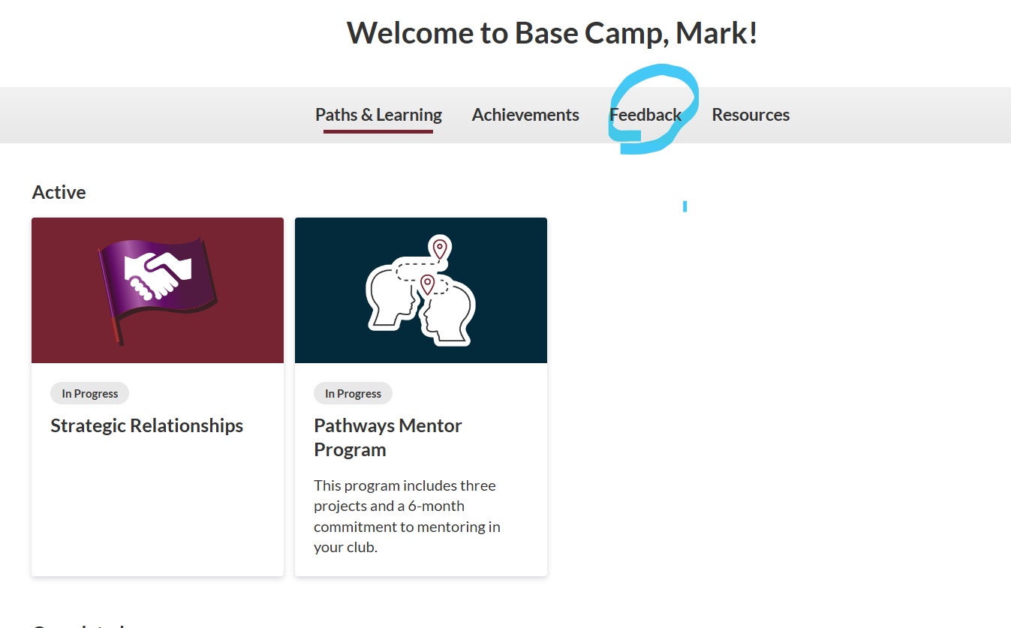
Step 3: Click on the Evaluation Feedback button
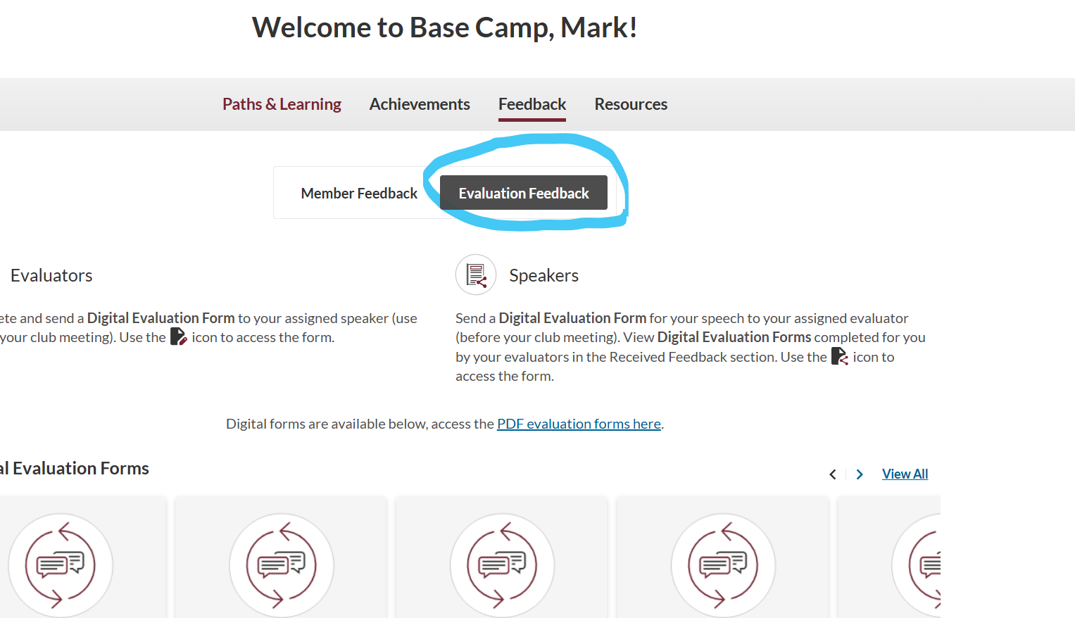

Step 4: Locate the Evaluation Form relevant to your speech project
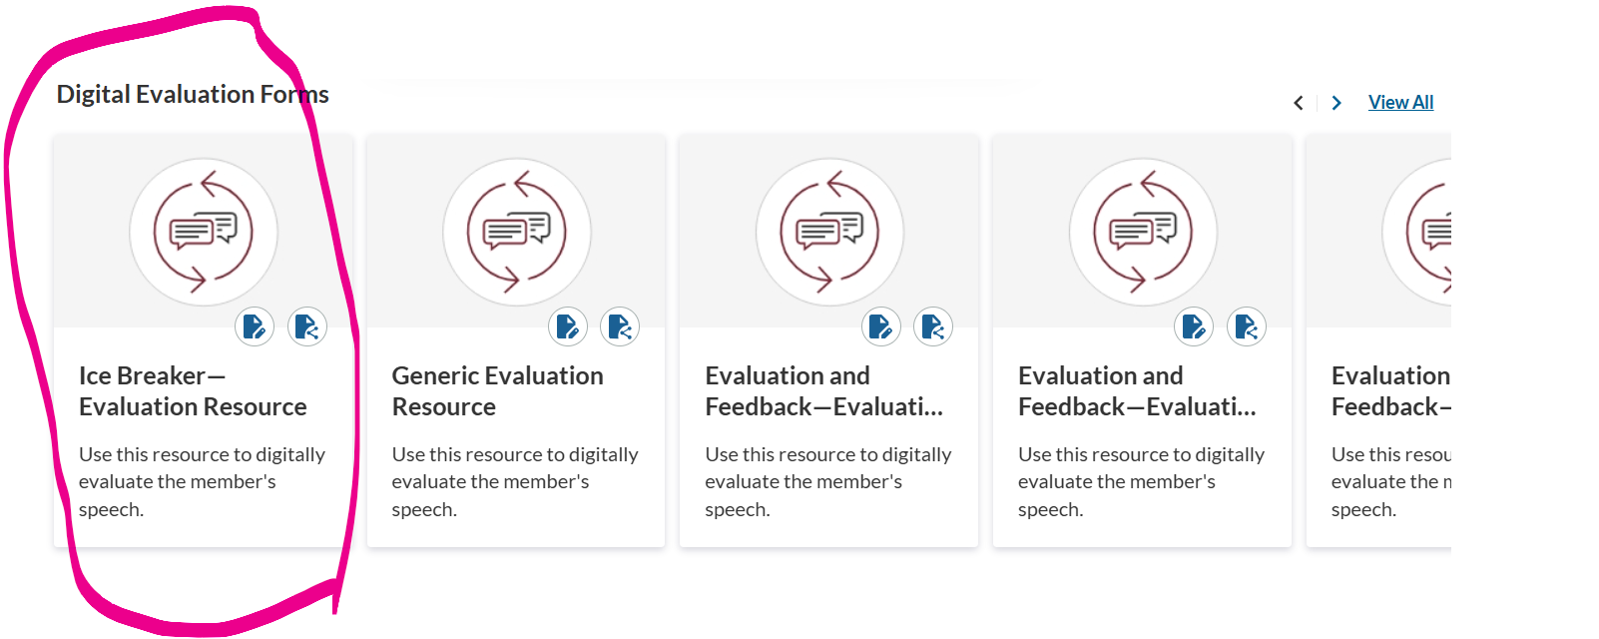

Step 5: Click on the little icon to send the form to your evaluator

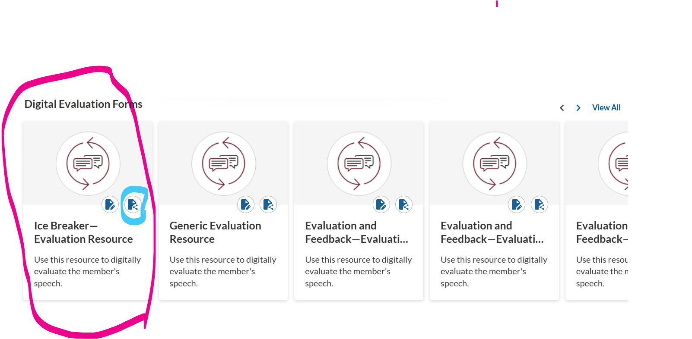
Step 6: Complete the form, select the person who is your assigned evaluator and hit the send button

